# CS 255 System Design Document Template

**Justin Swinney**

## UML Diagrams

### UML Use Case Diagram

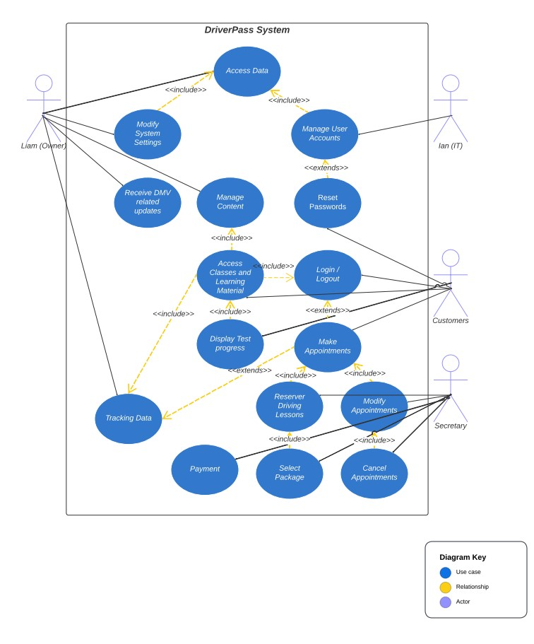

### UML Activity Diagrams

*Appointment Activity diagram:*

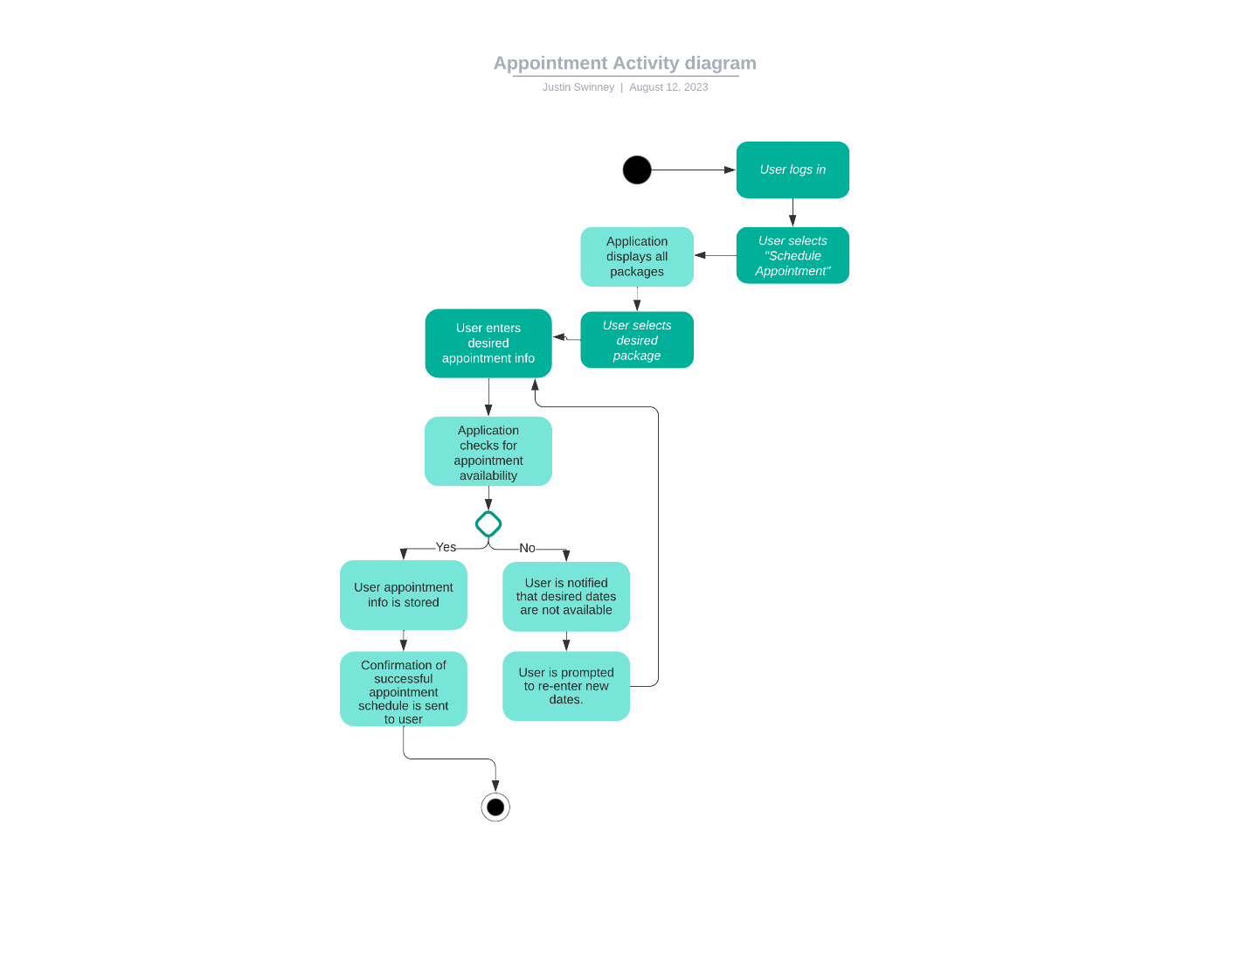

*Test Results Activity Diagram*

### UML Sequence Diagram

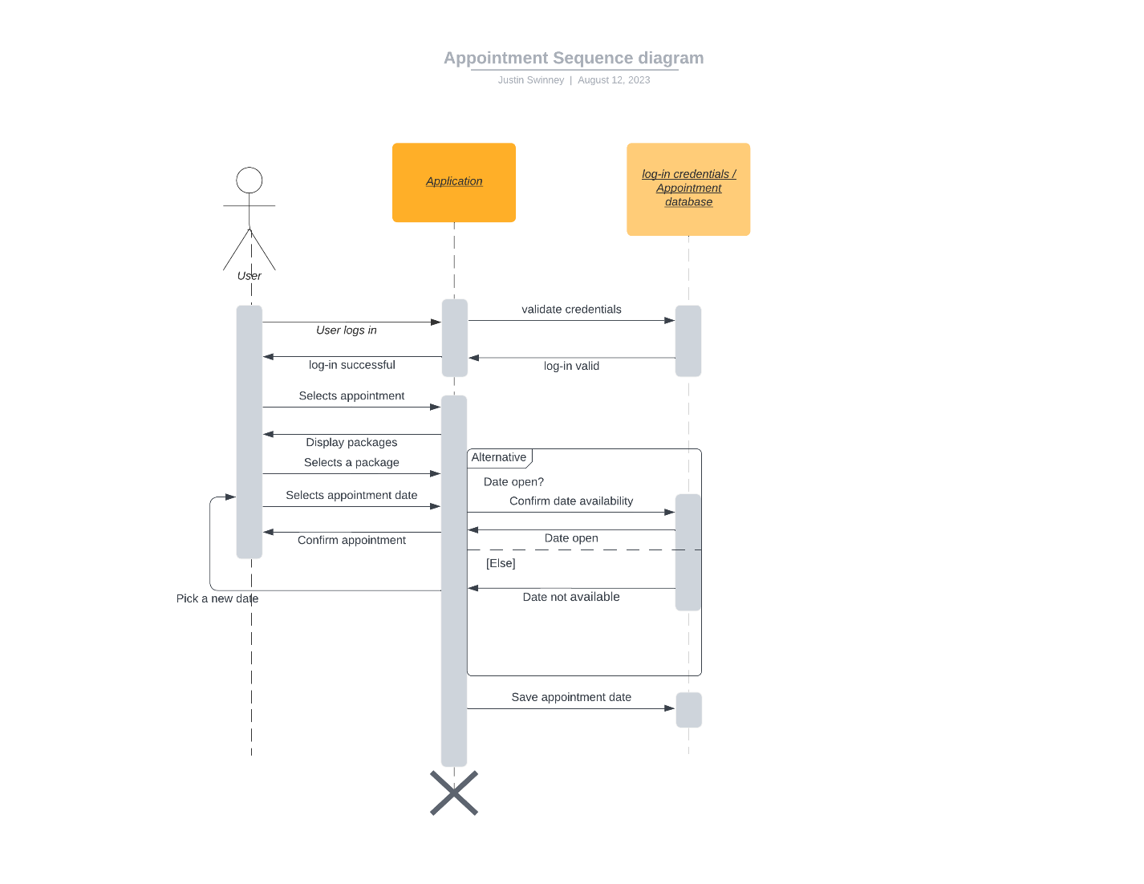

### UML Class Diagram

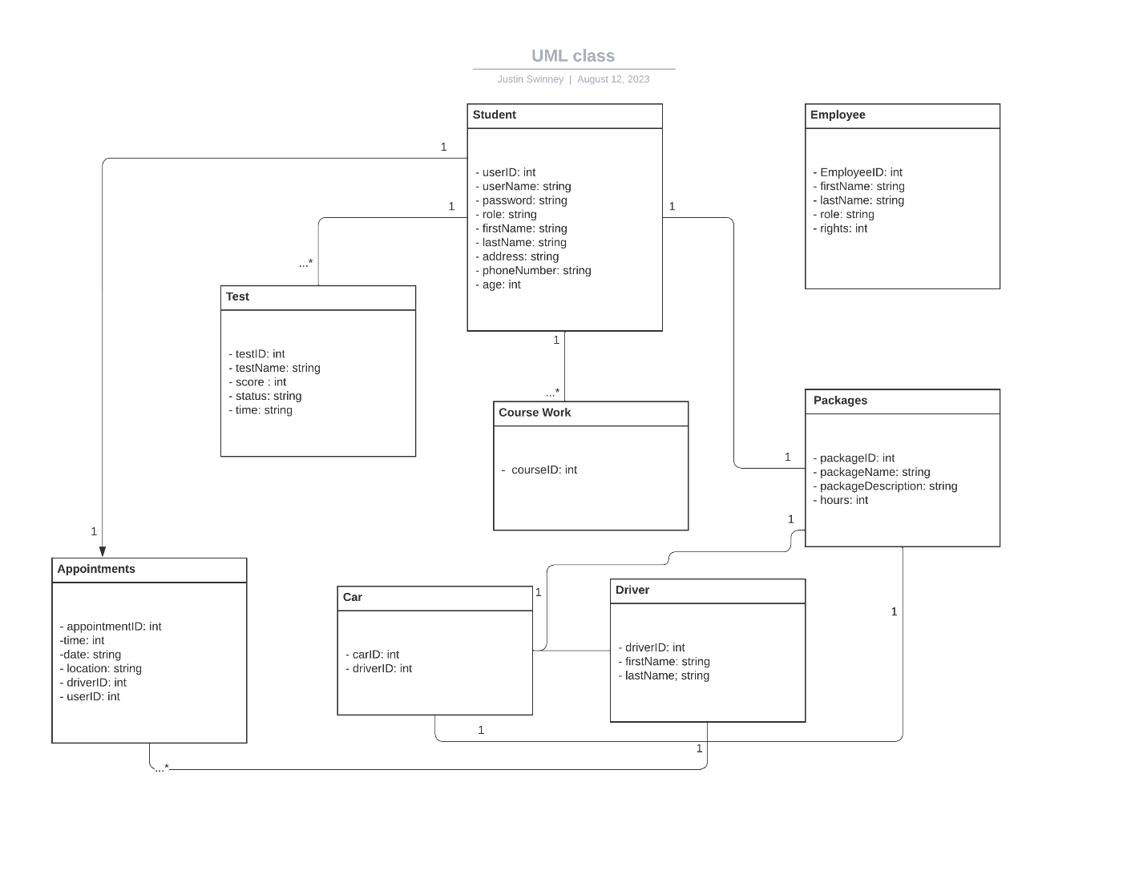

## Technical Requirements

Hardware:

* Web Server – Amazon S3
* Database Server – Amazon RDS
* Cloud infrastructure ideal

Infrastructure:

* Backup and recovery solution to handle unforeseen issues.
* Scalability – Amazon has solutions to handle scalability based on usage for potential money saving.
* Monitoring activity
* High speed internet

Software:

* Operating system – windows / Linux based ideal for web server / database.
* Database management – MySQL for data management and control.
* Development tools – IDE for web application – IntelliJ
* Web Framework – to handle interface and user input.
* Security tools – Encryption / Authentication and authorization of logins.